GAME DESIGN Report C17870 TRUMP ESCAPE/ LAND OF THE FREE THOMAS SIMMONS K1906250

Module Leaders: Hope Caton & Jarek Francik

# Contents:

Contents: 2

Introduction 3

Ideas: 3

Aims: 3

Game Origins: 4

My Version: 4

What inspired me? 5

Tom Clancy Games Storytelling: 5

Farming Simulator customisation 5

GTA V customisation options 6

HALO 3 ODST discovery system 6

NFS Carbon territory gaining and rewards: 7

Recent political events 7

Starting points 7

Evolution/ Development 8

Interim Presentation 8

Progression Chart development 9

Game Icons: 10

Game Logos: 11

Title Logos: 11

Faction Logos: 11

Game Map and Features 12

Map 12

City Representation 12

Outcome 13

What I have learned/ reflection of process 13

Future Development 13

Conclusion 13

References 14

# Introduction

This report is going to be about the origins and development of my game Trump Escape/ Land of the Free. Land of the free is a 3rd person role playing game at its core but also a game for every category of player. The four main categories of player fun are hard who are after personal goals and achievements, serious who are after excitement, easy who are after curiosity and surprise and people who are after amusement **(link 1).** I know it is very hard to include all these types of players into one game and do so successfully so I made it my aim to at least try to do so. The actions I will try to achieve from the players are goals achieving and strategy from hard fun players, exploration and creativity with easy players, collection and repetition with serious players and completion with people players **(Link 1).**

In this report I will be talking about the origins of this game idea and how I developed it, my aims and ideas after the origins game build, what inspired me to create this game and mechanics I liked in previous games which I want to implement, the evolution of the current game build and how I got there, the outcome of the most recent build of the game and finally the future development ideas **(Link 2).** Whist my main aims is to create a game for everyone to enjoy I also have a lot of personal interest in the game idea of a strategic game based on American politics and what could happen. The characters are also real people and follow what they have achieved and how they have disappointed the people around the world.

# Ideas:

My game idea is a game relating to current American politics, especially towards the actions on Donald Trump and his rule from 2016 to the present. This is a theme I have always been interested in and in my opinion make a great unique game genre. I researched into some of the main news stories towards American politics, how Trump has been involved and the consequences of every person or candidates actions. The player will be in the game world playing as Donald Trump during the time of decline for himself and American politics. His goal in the game world is to retake power in America and destroy anyone who’s in his way.

# Aims:

I am targeting the age group of 16 and above due to the high level of violence, moderate use of bad language, references towards discrimination and drug usage but due to the characters involved, the theme and storyline leaning towards fantasy the game shouldn’t be rated 18. My target market are players of all categories they partly or fully full into **(Link 1).** Players who are into communication towards allies and enemies who also love to complete games are “people players”, players who are into achievements within games and are strategic towards gameplay are “hard players”, players who are into exploring worlds and are creative are “easy players” and finally players who like replay ability and collection are “serious players”.

My aim for this game is to try and create a storyline, features and characters suitable for all these player categories by bringing in skill and challenge for hard players, expectation and storyline for easy players, relaxation and excitement from serious players and playing in groups or friends whist playing for people players. This is will a grave challenge but I think it’s possible with this game theme and style of play to attract all these players to my game.

# Game Origins:

This game was originally created as a two player board game called Hnefatafl **(link 3),** better known as Tablut **(Link 4)** which is a Viking game based game in the early medieval period or dark ages. The board is 11x11 square table where one side has twenty four pieces and another had twelve and one king, the rules and board itself on figure () are below:

* Aim of the team with twenty four pieces is to capture the King
* Aim of the team with twelve pieces is to help the king reach a corner of the board
* Movement is one square horizontally or vertically, no diagonal
* No piece can rest on the refuge or king starting squares
* Take pieces by squashing opponents pieces between two of your own
* If a legal move cannot be taken on their turn the game is a draw
* To take the king he has to be surrounded on all four sides
* Win condition is whether the king is captured or escapes.

## My Version:

I was tasked in a past assignment to iterate this game to help improve gameplay as well as keep the players engaged whist preventing any dominant strategy being made. I made several new rules on top of the current ones to do so, they are listed below:

* In the grey boundary on the board the king can move two spaces or one space diagonally across the board
* Can be player by 2-5 players
* Capturing pieces sends them to the red zones chosen by capturer on the map
* Turn the alliance of the piece giving control to another player
* Increased escape zones for king piece due to advantage of numbers by attackers
* Attacking players can work together or by themselves causing fights amongst each other

With these new rules my players where far more engaged to the game and lots of new strategies where formed. With the completion of this game when 5 players where playing and some teamed up with others whist some fought each other as well as trying to kill the king, the board design is shown below in figure (). This gave me the idea to implement politics into the game, specifically the America 2016 elections between Trump, Clinton, Sanders and other minor candidates **(link 5).** This was a great theme towards the players and as a result “Trump Escape” was formed.

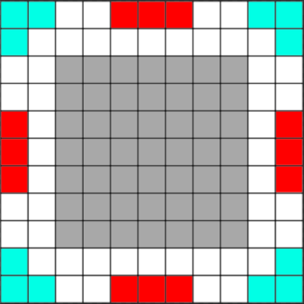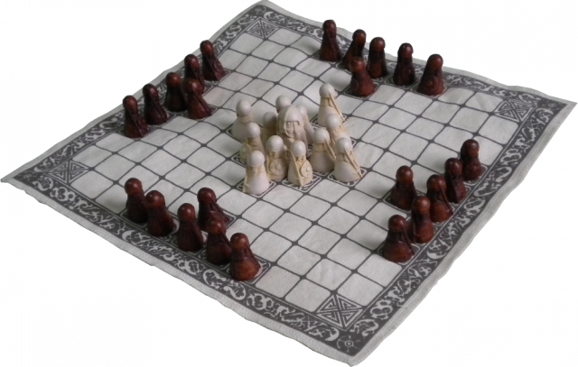

# What inspired me?

During the development of my game from the origins stage I played a lot of games and genres, some of which I completed and others got boring so what I will try to do is merge all the good parts of each game and its genre together to create a game where it’s for every type of player.

## Tom Clancy Games Storytelling:

I have always been a fan of Tom Clancy games, my three favourite game series of his are Ghost Recon, The Division and Rainbow and The Division is my favourite. This is due to the storyline and gameplay of this series. With the exception of the Rainbow series these games are 3rd person based where the player is either alone playing as a super soldier saving America from civil war caused by a plague called “dollar” in The Division or in a group of four trying to take down drug cartels or dictators in Ghost Recon. These stories are vast and lengthy but for a time can keep the player playing.

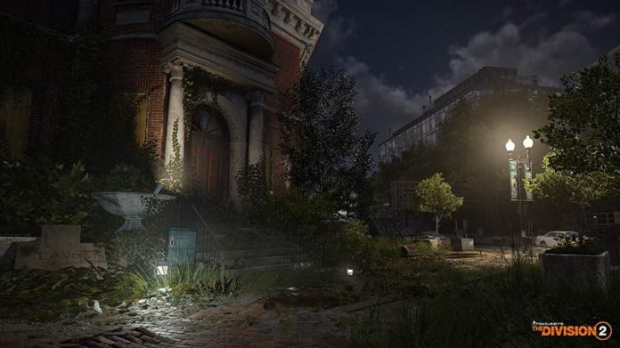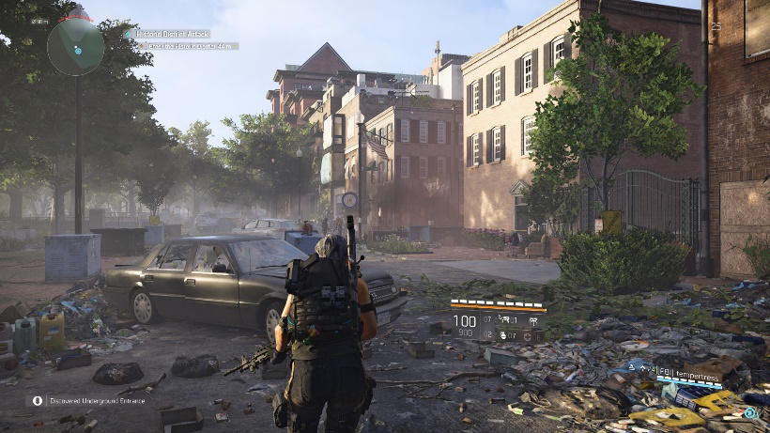Both these game series have a lot of side missions and activities the players can complete for extra rewards and experience to level up there character. Some of the mission relates to the main story missions, some are given to the player through discovery/ free roam and other are earned but completing other missions or completing tasks set by allies. All of these methods keep the players engaged to the game as well as the storyline. Below in figures () the scenery and player view of these games **(Link 6).**

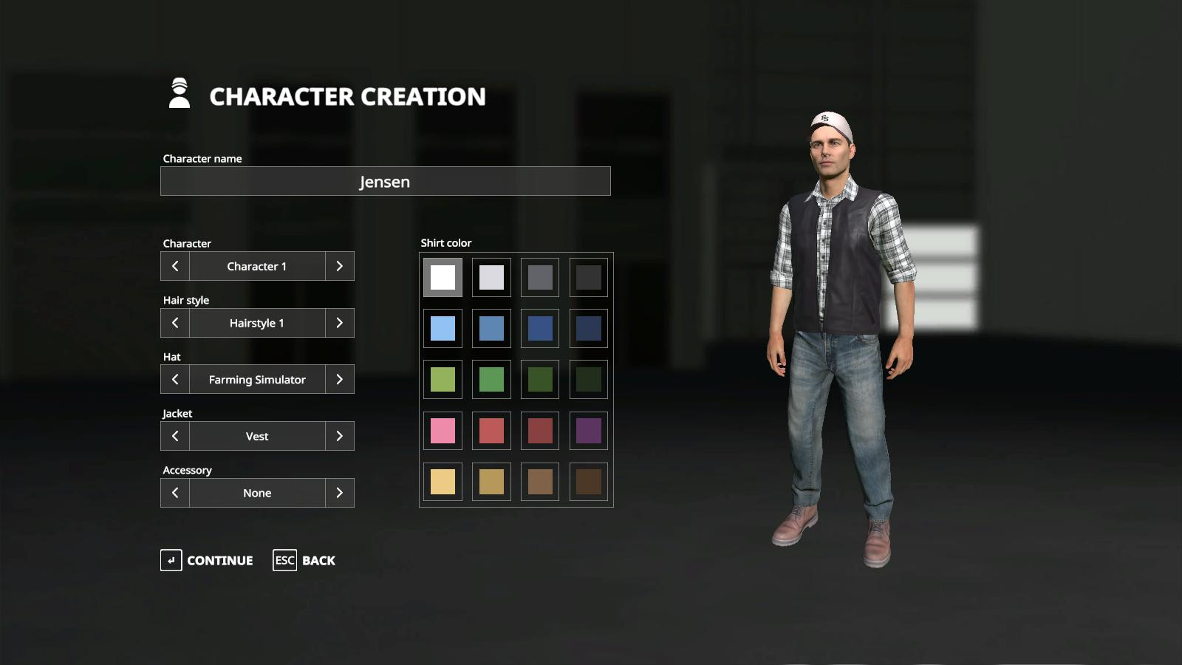

## Farming Simulator customisation

This game has been a major hit towards a lot of players around the world, this is due to its simplicity, relaxing and management skills being required. What I want to implement to my game its simplicity towards its character customisation options. On figure () you can see clear options to change character, hairstyles, hat, jacket and accessories as well as the colour options. This is very simple but clear to the player **(link 7).**

## GTA V customisation options

This game has had extremely high reviews from players of all kinds due to its gameplay, story, customisation and open world features such as killing anything and anyone such as police, soldiers and the public. There’s also a lot of drug and crime in this game which encourages players to do these actions but not get in trouble in the real world.

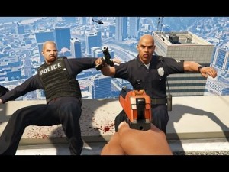What I want to implement from this game series are the free roam features **(Link 8)** and high character customisation options for the player **(Link 9).** These features will allow my players to create high detailed characters, or if they wish with the vast options available to them make their character look funny. The free roam features will also attract players who don’t care much about storyline and just want to go out and kill animals, people or police just because they can. This is shown in figures ()

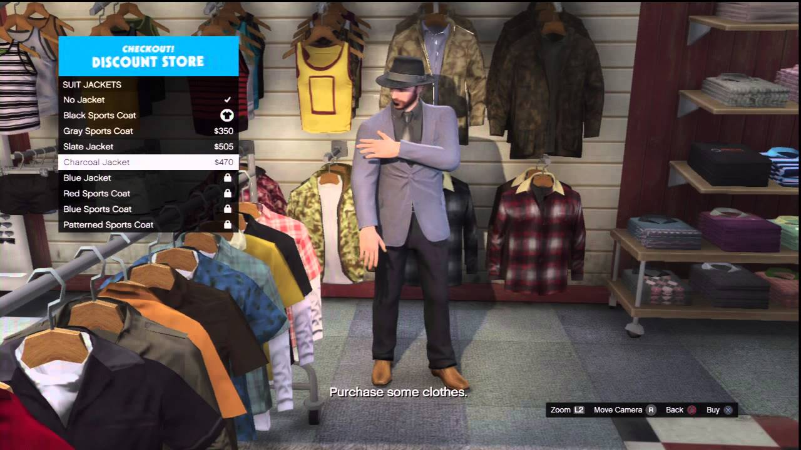

## HALO 3 ODST discovery system

Halo 3 ODST is a game in the Halo series based on a human alien war in the 26th century. The ODST (Orbital Shock Drop Trooper) spin off from Halo 3 is where the player plays as a human rather than a Spartan super soldier. The idea of this game was to make players feel a lot more vulnerable towards the much superior enemy forces causing players to have to strategize a lot more during gameplay.

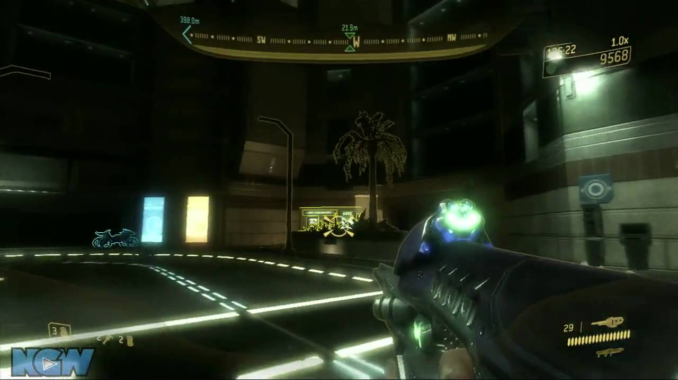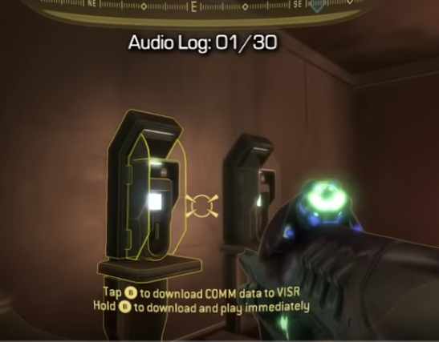What I want to implement from this game is the discovery of collectables system this game has. How the player discovers collectables is a clear district colour difference compared to the scenery as well as audio being used to create a ringing, much like a mobile phone sound which gets louder and clearer as the player gets closer, vice versa towards moving further away **(Link 10),** this is shown in figures ()

## NFS Carbon territory gaining and rewards:

Need For Speed Carbon is a racing game where the player has to complete races of different kinds and by winning the majority of races they capture the territory in question. They win extra rewards for taking that territory such as cars, visuals and respect. After capturing all these zones the boss offers you a race to gain complete control of that area in question, after winning the races against the boss the player gains a big reward such as big boosts in cash, discounts and even the boss’s car.

However this works both ways meaning if a faction wins the majority of races in your controlled zone they take over as well as take the rewards you earned from that zone away from the player. This system explanation is shown on figures () between 18:44 to 19:10 on the given reference **(Link 11)**

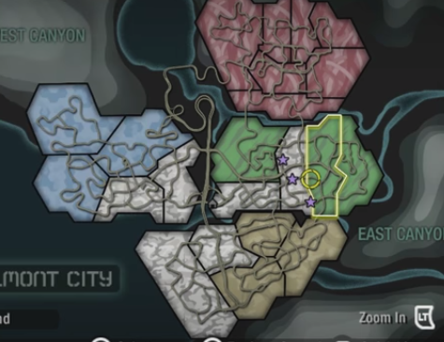What I want to implement from this game is this exact system of zone/ territory capture system but towards activities and side missions the player will need to complete. As they are taken away from them the player loses influence in that sector/ territory, which risks losing rewards gained and territory lost to the main enemies or minor factions. This can cause a lot of distractions from the main goals of the player if they’re territory isn’t managed properly.

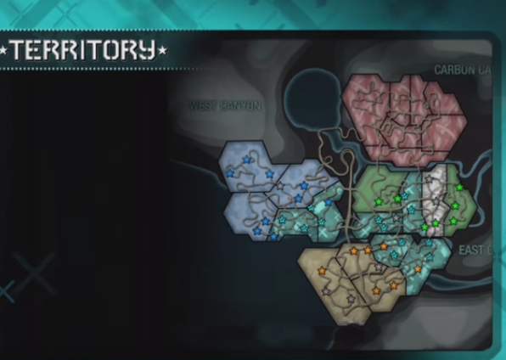

## Recent political events

One of my main inspirations to create this game is the American political situation from the last election in 2016 to everything that has happened till the present day. This includes the accusations towards Donald Trump and his impeachment affairs, as well as the opinions, news stories and future consequences. Also to my knowledge nobody has created a 3rd personal role playing game where they play as famous political figures.

# Starting points

When I received my project brief I started working on the layout of my Game Design Document (GDD). I used the recommended 10 pager appendix given to us with all relevant documentation and left notes under each section on what to write and how to write it. Using these notes and bullet points helped me remember what to write and not stray away from the topic in question.

The sections included a title page which includes the target market, game outline which briefly explains the story and the game flow including progression and reward systems, the characters in the game, gameplay including the storyline/s and winning requirements, players experiences, mechanics used, enemies encountered, multiplayer and in game stores and finally monetization. I had all of these to think about at the beginning and during the development of my game.

# Evolution/ Development

## Interim Presentation

This presentation was an opportunity to show my fellow developers and lecturers what my intended game ideas, future development, why I have chosen this idea and intended target market. This also helps the audience understand my game and what they have to do in order to win.

### Summary of America Down Under:

When the player first starts the game they watch a backstory scene of Donald Trump during the time of impeachment. His enemies find proof via paperwork and witnesses saying he used the Russians to help in his 2016 election campaign, he doesn’t believe them forcing them to release the truth the world. This is now the start of the game.

The player starts in Washington DC at the White House as Donald Trump defending from enemy forces sent by an unknown enemy. In this opening mission the players are introduced to the basic movement and shooting mechanics in order to kill the enemy forces offensive. They are hen introduced to the throwing and communication mechanics. Once the mission is near complete they are introduced to the first collectable showing the player where the rest of Donald’s enemies are and who they follow.

### Feedback towards Presentation:

* Include audio used in game such as voices from characters, music in situations and sounds such as explosions and bullets.
* Have small pauses during the presentation so listeners can keep up
* Include small videos of gameplay such as the main mechanics and the level creations.
* Include current games that have similar game mechanics, aesthetics and inspiration
* Include a slide on in game purchases such as DLC and Loot boxes to bring in more revenue.
* Represent game loops/ sub game loops
* Make presentation background relatable to the game idea

### Feedback towards Gameplay

* Have the player play in first person and they don't know who their character is until they find a reflective surface and find out who they are.
* Have the option to play as other political characters so players can choose how they want to be represented in game. For Example Trump, Clinton and Obama
* Include dramatic music in certain scenarios to help bring up the suspense towards the player
* Have an audio system to inform the player that something (good or bad) are close.
* Maybe have some cut scenes towards some gameplay scenarios such as being killed or killing a boss/ major enemy
* To help make the game for balanced include some good and bad traits towards the political characters the players can play as well as are against.

The feedback I received was generally good, the main criticism I got was the lack of character choice and the story lines. What I have decided to do with these issues is to allow the player to choose a character they want to play as during the main story campaign, they can pick Trump, Clinton or Obama. All three characters will have positive and negative traits/buffs to help game balance the choices of characters. All three characters will also have three different story lines with three different goals and methods to reach it. There’s also an opportunity for the player to kill the opposing candidates during gameplay.

## Progression Chart development

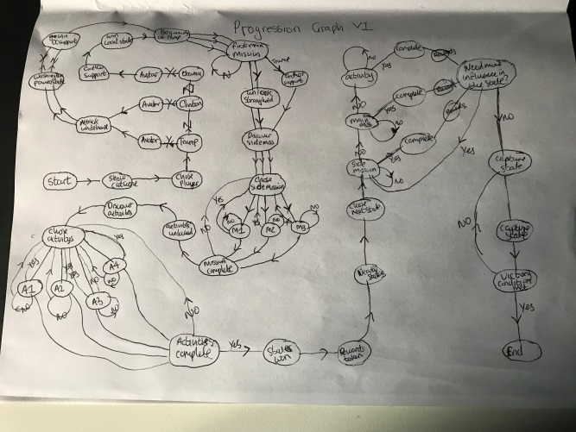To create my progression chart I used my storyline at the time as a guide, what events might occur during gameplay, there endgames and potential DLC.

### First Iteration:

In my first version of the progression chart I concentrated on the content towards the storyline over the layout and neatness. I used an A4 piece of plain white paper. I followed the gameplay plan updated from the interim project presentation, as a result the main actions towards gameplay and player choice are represented in the chart with the option “yes” and “no” having immediate effects. This shown on figure ()

### Second Iteration:

In my second version I included the downloadable content (DLC) options the player will have available to purchase and where they can use what they have bought. For example DLC characters, customisations, missions and scenarios. Also the main actions on the chart are related to what they stand for such as circle is a process and multiple boxes mean multiple choices for the player. This is shown on figure ()

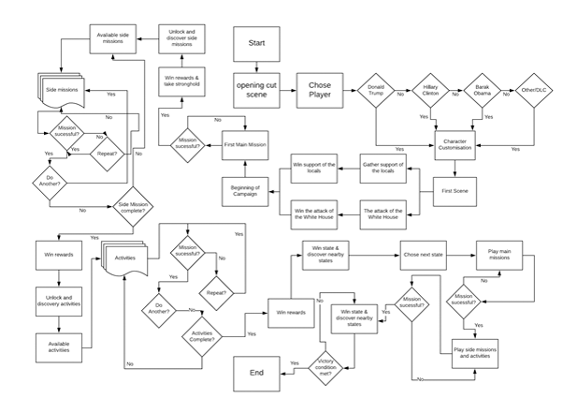

### Third Iteration:

In my third iteration I used a chart creating company online called “Lucidchart” **(Link 12)** to make my progression chart using my drafts on paper. This site allowed me to make every action the player has to be represented correctly. These include a square for a process, diamond for a question and multiple squares back to back for multiple choices. This is shown on figure ()

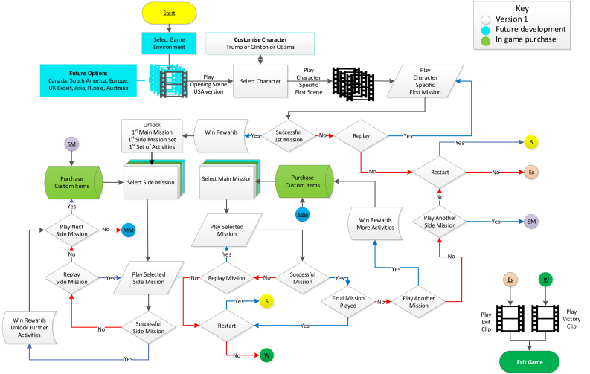

### Fourth Iteration:

Once I created my chart using “Lucidchart” I noticed it was very crowded and somewhat hard to follow. I discovered “Microsoft Visio” and chose to recreate my chart on its system. This was a grave help due to the clear choices, representations and colours. I used the video icon for video scenes, A key with colours for the reader to follow and understand and also shortcuts to the chart so it doesn’t look crowded. This is shown on figure ()

## Game Icons:

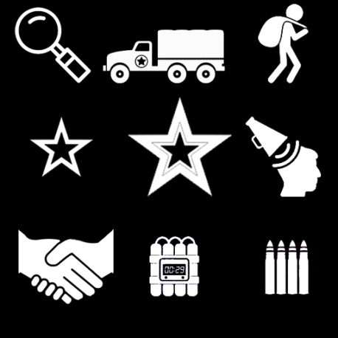Below are the games icons that will help the player know what missions and activities they’ll be doing and what rewards they can potentially earn for the completion of them.

### Mission & Activity:

These icons on figure () inform the player what missions, activities or main story mission they are setting to reach as well as an idea what they will be required to do. The first three icons represent discovery such as information gathering, hijacking an enemy convoy and looting abandoned areas. The following three represent side missions, main story missions and propaganda towards enemies and allies. The last three represent negotiations, timed explosive and ammo replenishment.

### Locations and character traits:

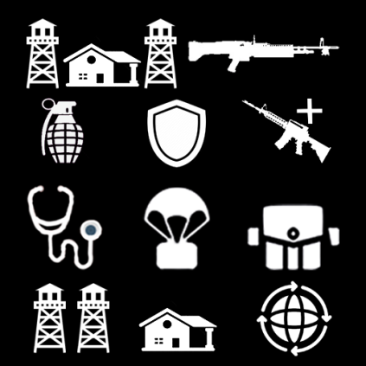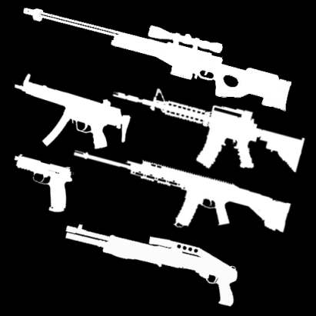These icons on figure () inform the player what locations of interest they might want to investigate as well as the actions or reward’s the character they have chosen can do complete or get. The top two represent a stronghold location and light machine guns which only Donald’s character can acquire. The next three represent explosives, armouries which only Clinton character can acquire and weapons base locations. The next three are Hospital location where the player can get more health; weapons air drops locations and appearance locations. The last three are fortified areas of interest, safe houses and international negotiations which only Obama has access too. These can be accessible for any characters through discovery and negotiations.

### Weapons:

These icons on figure () inform the player what type of weapons they have available to them on the weapon selection screens, mission rewards and loot able locations.

### Health Variations:

These icons on figure () show the options the player can use, upgrade and equip health. The first three on top represent health usage reloading, sharing health with allies and a loot able health kit. The next three represent acquiring more health packs, upgrading the effectiveness of health usage and adrenaline. The last three represent forging more health packs, drugs and injections.

### Inspiration

To create these logos I used the some of the designs from The Division 2 (link 13) and Wildlands (link 14) as well as some designs I created myself.

## Game Logos:

## Title Logos:

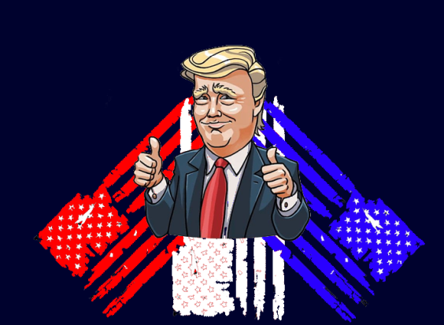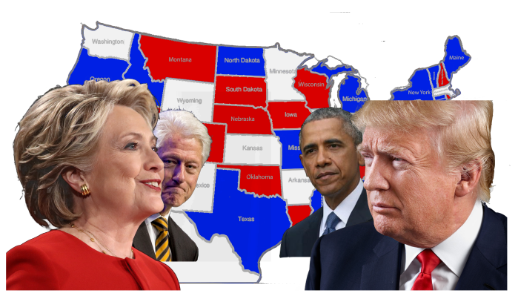On figure () is my game case and main menu logo for the console platform. It features all the main characters including Hillary (Link 15), Trump (Link 16), Obama (Link 17) and Bill Clinton (Link 18) having a face off amongst each other. In the centre of the logo shows a map of America and all its state names. Designing the map behind the Candidates will give the impression to any player with a console the impression of a battleground/ scene for power. The logo on figure () is my game logo for players who download the game off of the Apple or Android stores. It features Donald Trump with his Thumbs up (Link 19) and three American flags behind them. This is supposed to draw players who are into all kinds of mobile game. This is a work in progress.

## Faction Logos:

### Donald Trump

The faction logo on figure () will be representing Donald Trump’s faction. It shows himself on the front with his thumbs up (link 16). It has two American flags behind him; some of the state represented with a star is missing due to his acknowledgement of these states being relatively minor to him. His slogan “make America great again” is his 2016 election slogan campaign, this is to show that he thinks his ways are correct.

### Hillary Clinton:

This faction logo on figure () will be representing Hillary Clinton’s faction. On the front there’s a photo of Hillary holding a pistol and aiming straight towards her enemies (link 20), whist Bill is hidden behind her. This is supposed to install fear into her enemies through intimidation. Her slogan “keep calm it’s my turn” refers to her allies to tell them whatever happens she will take power from Trump.

### Barack Obama:

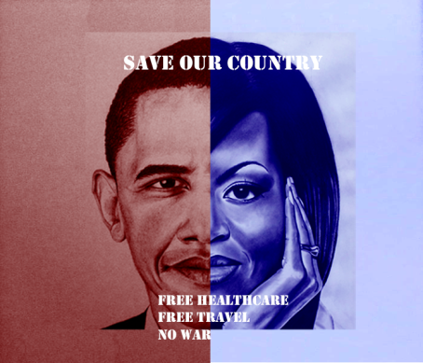The faction logo on figure () will be representing Barack Obama’s faction. In the centre of the flag shows an image of Barack and his wife Michelle split half and half with one side being shaded red and the other blue. This is supposed to represent equality amongst gender and colour. This title slogan “Save our Country” is supposed to appeal to the public who have suffered and wish to stop there country being destroyed due to politics. His secondary slogans show what he plans to do after the war is over.

# Game Map and Features

## Map

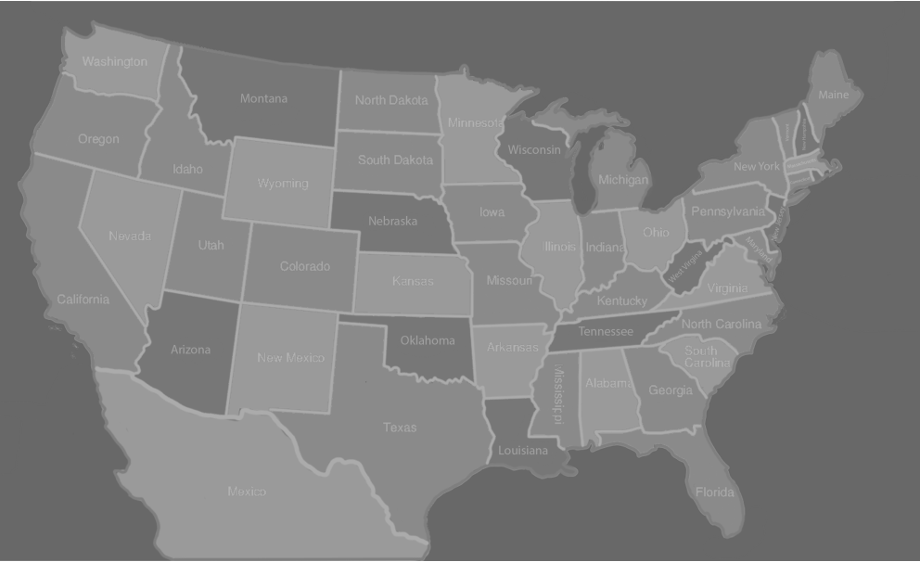This game map is where the player will always be located during gameplay (Link 21). They will have to navigate their way around America coming missions and activities to progress. He player cannot get into the next city or state on their agenda until they have successfully completed the main story missions. The player cannot access Mexico unless they are Donald Trump and chose the escape option in his storyline. This is shown below on figure ().

## City Representation

On the game map there are also cities where the player can complete side and activities in order to capture and win its rewards. These cities give a major boost to the influence requirements in its state so the player can progress and win the rewards on offer. The cities the player will be able to see are the capitals of each state as well as any cities with any iconic landmarks (Link 22) or owned buildings by the character (link 23) such as the trump towers. Examples are shown in figures ()

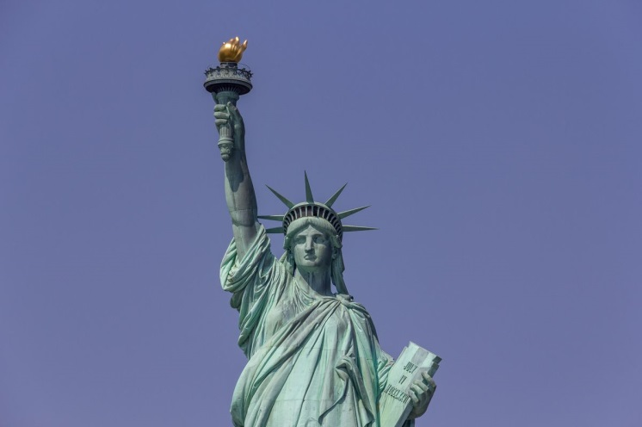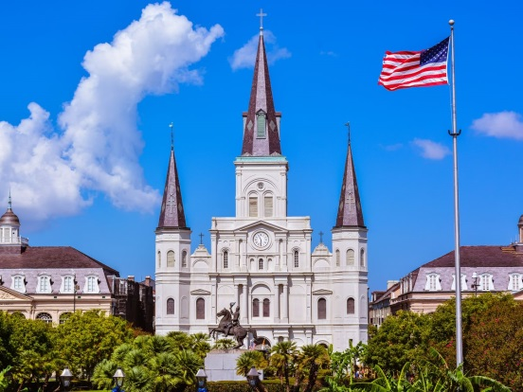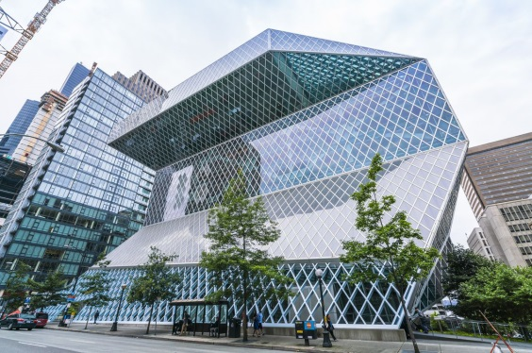

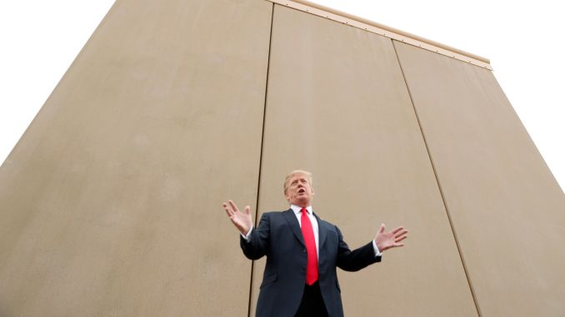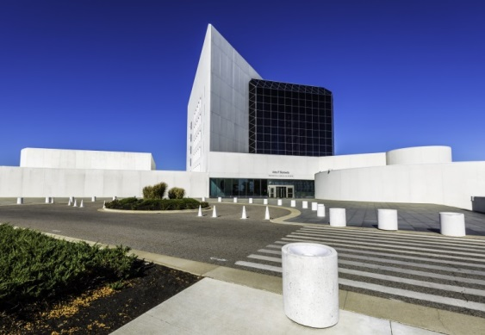

# Artefact:

As part of this module I am required to provide a playable prototype of the game as well as any created or downloaded assets used. The diagrams, storyline and storyboards must be used as a guide to create the game using the preferred software and game engine to present my game design as well as provide video footage of the player playing.

## Artefacts Created

Below are all the clothing artefacts created using Autodesk Maya 2019 whist using video guides as well as my own skills using reference images. These models will then be imported into a game engine and included in the character customisation screen so the player can select the item and include it on their character they’ve selected.

### Head & Face Customisation

In the game there are my head model assets such as a variation of hats the player can select in the customisation menu. The asset was created on Autodesk Maya 2019 using the methods of extruding, scale, connect, soft selection and smoothing tools. Using these given tools, the models created where a cap/ snapback, tweed hat, brim hat and a felt hat. These are shown on the GIF links below. I used reference images with rotation options, guild line videos and photos taken by myself to create these assets. For the cap (KG, A 2020) and felt hat (link 25) and video (link 27) I used a rotatable references as a guide, the brim hat (link 26) I used static images and finally I used my own tweed hat as a reference to complete these models. Examples on figures () and the first GIF link shows these models.

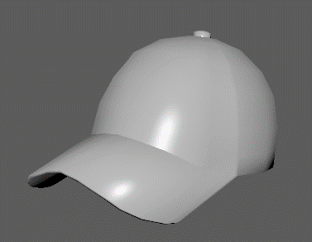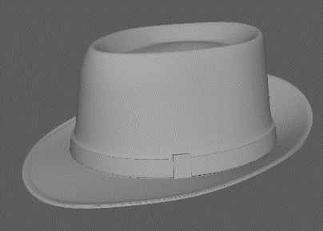

### Face Customisation

The next category of assets are my face models, specifically different variation of glasses the player has access to in the customisation screen. They were created using the same tools as the hats as well as being smoothed in certain sections rather than the whole object, but with the addition of using the mirror tool to save time, avoid illegal polys and being perfectly symmetric.

I used a variety of different guide videos and reference images to complete these models, the first pair was created using (link 28) images, the second using (link 29), the third using (link 30) and the last using (link 31) and then adding several holes in the middle. Examples are shown below in figures () and the second GIF link shows these models.

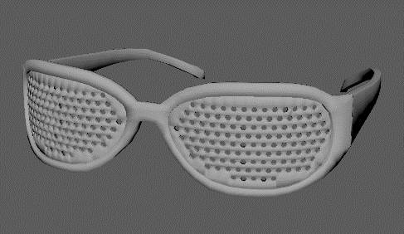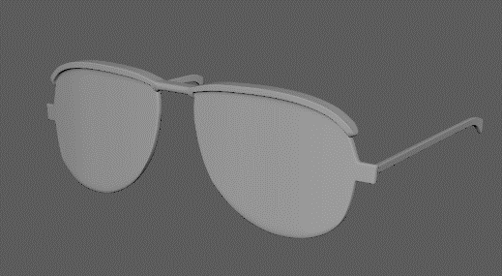

### Upper & lower body customisation

The next category of assets are my upper and lower models which the player has access to in the customisation screen. They were created using the same tools previously specified but this time using the soft selection tool and curving a lot of the hard edges in order to add fabric creases and folds to the models. Examples are shown below of figures () and the third GIF link shows them all.

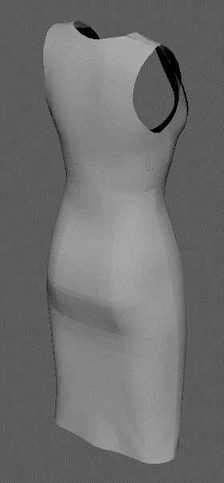I used a variety of videos to help guide me along the process of these models, however some models proved to be to challenging for me so then the models where downloaded from Sketchfab and Turbosquids online free 3D models library to help fill in the models required. These included shirts (link 32), jumpers (link 33), dresses (link 34, 35) and trousers (link 36). The fourth GIF will show them all.

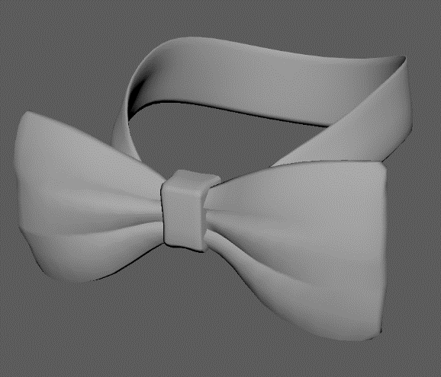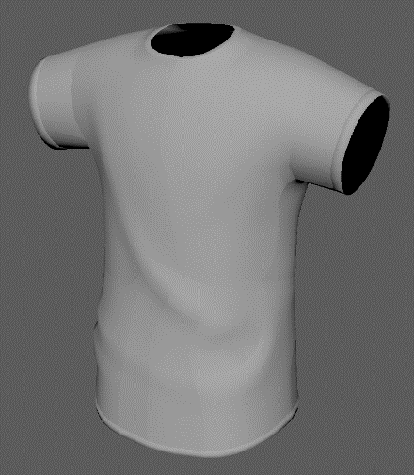

### Footwear Customisation

## Character Artefacts

Adobe Fuse Development

### GIF links to Models

<https://media.giphy.com/media/VEVSd6u6W72EZqqzcs/giphy.gif>

<https://media.giphy.com/media/LnLW06jY0YrHGIi00E/giphy.gif>

<https://media.giphy.com/media/VJrt7kVjPHo6t8a48R/giphy.gif>

<https://media.giphy.com/media/cM3Ddd3IvXeHg7tTbu/giphy.gif>

## Prototype

### Menu Screens

### Customisation screen

# Outcome

* Complete 3d models which can be used
* Character creation skills from fuse
* Story telling skills
* Character customisation screens
* Reaction from fellow students and lecturers

# Future Development

* Create variations of weapon, armour, explosives and negotiation HUD icons
* Introduction Levels for all three Characters
* More customisation options
* Create city landmark locations on map
* Make title logo look less like an election campaign
* Very short what I wanted to achieve with my prototype

# Conclusion

* What I have learned/ reflection of process
* How to use Autodesk Maya more effectively
* Where I can get detailed models to use
* How to use adobe fuse
* How to use Visio to create charts effectively.

# References

1. <https://www.nicolelazzaro.com/the4-keys-to-fun/>
2. <https://www.monash.edu/rlo/assignment-samples/engineering/eng-writing-technical-reports/introduction>
3. <http://www.cyningstan.com/game/221/hnefatafl>
4. <https://healthy.uwaterloo.ca/museum/VirtualExhibits/Vikings/Tafl/viking/index.html>
5. <https://www.nytimes.com/interactive/2016/us/elections/2016-presidential-candidates.html>
6. <https://www.gamespew.com/2019/02/the-division-2s-new-scenery-is-enough-to-draw-me-back-in/>
7. <https://www.scholarlygamers.com/news/2018/10/10/farming-simulator-19-developer-blog-character-customization/>
8. <https://www.meme-arsenal.com/en/create/template/27675>
9. <https://www.youtube.com/watch?v=nKTT0cYybkc>
10. <https://www.youtube.com/watch?v=wvhBG-cSQKU>
11. <https://www.youtube.com/watch?v=_IJQITAnMdg>
12. <https://www.lucidchart.com/users/login>
13. <https://www.saracheung.com/?p=403>
14. <https://imgur.com/r/GhostRecon/D9Dh2kv>
15. <https://time.com/4519718/donald-trump-hillary-clinton-change/>
16. <https://time.com/time-person-of-the-year-2015-runner-up-donald-trump/>
17. <https://edition.cnn.com/politics/live-news/impeachment-inquiry-12-17-2019/h_76b39dda6a6678af6d1c6f09a76ea359>
18. <https://www.mic.com/articles/122391/bill-clinton-admits-he-made-one-huge-mistake-during-his-presidency>
19. <https://favpng.com/png_view/united-states-telegram-united-states-donald-trump-sticker-illustrator-png/GyY197fs>
20. <https://www.rollingstone.com/culture/culture-news/meet-the-controversial-artist-who-creates-surreal-paintings-of-hillary-clinton-33450/>
21. <https://www.mhpbooks.com/the-onion-most-read-news-source-in-minnesota-wisconsin-and-new-mexico/>
22. <https://www.curbed.com/2017/11/15/16656780/best-architecture-united-states-cities>
23. <https://www.esquire.com/news-politics/politics/a26965814/trump-tower-chicago-retail-failure/>
24. KG, A. (2020). *Liberty Baseball Cap - 8,95 £*.Hatshopping Shop. Available at: <https://hatshopping.co.uk/Liberty-Baseball-Cap.html> [Accessed 5 Dec. 2019].
25. <https://www.jenniferouellette.com/winter-wonderland/3501-m44-mens-felt-hat-with-wide-brim.html>
26. <https://www.pinterest.co.uk/pin/343047696613659950/>
27. <https://www.youtube.com/watch?v=ACcqG9bkmRc>
28. <https://www.uberpanache.com/getting-the-black-tinge-on-your-eyes-worlds-most-expensive-sunglasses-e36db409>
29. <https://www.zumiez.com/ray-ban-clubmaster-black-and-gold-sunglasses.html>
30. <https://taylormorriseyewear.com/collections/the-zero/products/zero-c10>
31. <https://www.alibaba.com/product-detail/FDA-Certification-new-design-fashion-cheap_60323422473.html>
32. <https://sketchfab.com/3d-models/shirt-745d0d185b49405694ef4e16cf78e224>
33. <https://www.turbosquid.com/FullPreview/Index.cfm/ID/1109145>
34. <https://www.turbosquid.com/3d-models/free-max-mode-amy-0-female-character/454342>
35. <https://www.turbosquid.com/3d-models/dress-lace-female-mannequin-3d-3ds/841802>
36. <https://sketchfab.com/3d-models/jeans-thic-7aba73c660a744f193388a9288deb859>